Levenhuk Promotion

Levenhuk Telescopes Promotion | Levenhuk Zongo Telescope Cases

You should offer cases to all telescope buyers, telling them, that it is convenient to store or transport the telescope in the case.

Levenhuk Zongo 20 Telescope Case; Small, Black  This bag is suitable for most refractors 50, 60, 70, 80 mm as well as Maksutov-Cassegrain telescopes 80, 90 mm and reflectors 76 mm.  Thanks to the padded divider inside Levenhuk Zongo 20, you can store the telescope tube and the tripod separately. For even more protection, counterweights are held in place with hook-and-loop fasteners. Any and all accessories you may have will easily fit inside a pocket in front. | 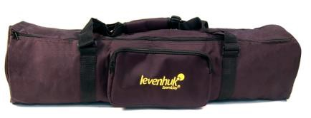  Product ID: 37466
Levenhuk Zongo 40 Telescope Case; Large, Black  This capacious bag is suitable for storing and transporting the vast majority of refractors 50, 60, 70, 80, 90, 100 mm as well as Maksutov-Cassegrain telescopes 80, 90, 102, 127, 150 mm and reflectors 76, 114, 130 mm.  The telescope case consists of two items:  - The main bag with an additional pocket that can hold your telescope tube, mount, accessory tray, and all your accessories inside.  It even has a shoulder strap for easy transportation.  - The pouch for your tripod that you can sling over your shoulder. | 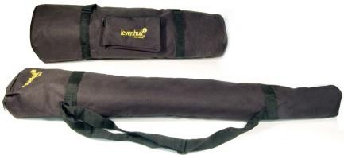  Product ID: 37465
Levenhuk Zongo 60 Telescope Case; Small, Blue  This handy bag is designed for transporting small telescopes such as Maksutov-Cassegrain 80, 90 and 102 mm. The Levenhuk Zongo 60 Telescope Case is made of durable nylon that allow for safe storing of your telescope.  The telescope case consists of two items:  - The main bag with additional pockets that can hold your telescope tube, mount, accessory tray, and all your accessories inside. It even has a shoulder strap for easy transportation.  - The pouch for your tripod that you can sling over your shoulder. | 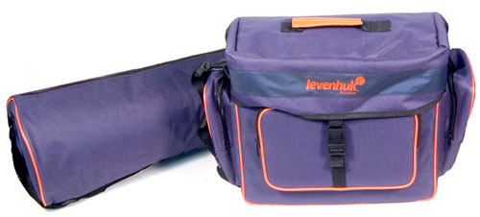  Product ID: 37623
Levenhuk Zongo 80 Telescope Case; Large, Blue  This capacious bag is suitable for storing and transporting the vast majority of refractors 50, 60, 70, 80, 90 mm as well as Maksutov-Cassegrain telescopes 80, 90, 102 mm and reflectors 76, 114 mm.  The Levenhuk Zongo 80 Telescope Case is made of durable nylon that protects your telescope from any impacts while transported, and from dust and moisture while stored.  The bag consists of one large compartment with an internal padded divider. You can hold the telescope tube itself, along with a mount, an accessory tray, and a tripod in this case. The bag features convenient wide handles and a wide strap. | 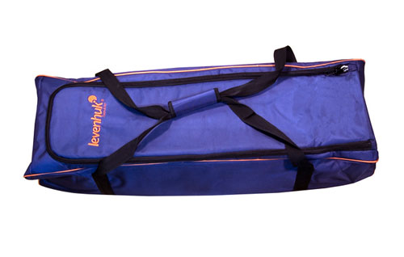  Product ID: 37624

Levenhuk Telescopes Promotion | Levenhuk Skyline Series
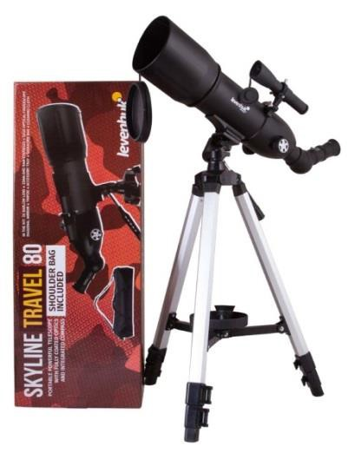
This series includes a variety of telescopes suitable for beginners. These telescopes are installed on alt-azimuth and equatorial mounts. The Levenhuk Skyline series has multi-coated optics that allows for observing the Solar System objects, terrestrial objects and some nebulae and star clusters. The telescopes carry a lifetime warranty.

Levenhuk Blitz BASE Series  The initial series of refractors and reflectors for novice astronomers. The difference from the Blitz PLUS series is a simpler azimuth (AZ) mount.  This series is ideal for kids.  The series includes:  77098 Levenhuk Blitz 50 BASE  77099 Levenhuk Blitz 60 BASE  77101 Levenhuk Blitz 70 BASE 77100 Levenhuk Blitz 70s BASE 77102 Levenhuk Blitz 76 BASE  77103 Levenhuk Blitz 114 BASE | Levenhuk Blitz PLUS Series  These are entry-level refractors and reflectors with additional accessories in the kit. They feature equatorial (EQ) mounts. This mount production costs is higher, but it is easier to operate. It is suitable for beginners with a strong interest in astronomy.  The series includes:  77109 Levenhuk Blitz 80s PLUS 77110 Levenhuk Blitz 80 PLUS  77104 Levenhuk Blitz 76 PLUS  77108 Levenhuk Blitz 70 PLUS  77107 Levenhuk Blitz 203 PLUS 77105 Levenhuk Blitz 114s PLUS 77106 Levenhuk Blitz 114 PLUS
Levenhuk Skyline Travel Series  These compact and lightweight refractors feature azimuth mounts. They have such as an extended kit as the telescopes of the Skyline Travel Sun series have, but the solar filter is not included.  The series includes:  70817 Levenhuk Skyline Travel 50  70818 Levenhuk Skyline Travel 70  72053 Levenhuk Skyline Travel 80 | Levenhuk Skyline Travel Sun Series  These lightweight refractors are user-friendly, so not only adults, but also children will figure out how to operate them.  These optical tools come with a convenient branded backpack that will easily hold a tube, mount, tripod, and all accessories. This series features a solar filter in the kit.  The series includes:  71996 Levenhuk Skyline Travel Sun 50  72481 Levenhuk Skyline Travel Sun 70
Levenhuk Skyline BASE Series  Each telescope of this series comes with an extended set of optical accessories that allow you to start observing right away. The difference from the Skyline PLUS series is a simpler azimuth (AZ) mount. This series could be recommended for kids and beginners.  The series includes:  72847 Levenhuk Skyline BASE 60T 72846 Levenhuk Skyline BASE 50T 72848 Levenhuk Skyline BASE 70T 72850 Levenhuk Skyline BASE 80T 72849 Levenhuk Skyline BASE 80S 72851 Levenhuk Skyline BASE 100S 73800 Levenhuk Skyline BASE 110S 72852 Levenhuk Skyline BASE 120S 73801 Levenhuk Skyline BASE 130S | Levenhuk Skyline PLUS Series  These are entry-level refractors and reflectors as well as catadioptric telescopes with additional accessories in the kit. They feature equatorial (EQ) mounts. This mount production costs is higher, but it is easier to operate. These telescopes are designed for beginners as well as experienced users.  The series includes:  72853 Levenhuk Skyline PLUS 60T 73802 Levenhuk Skyline PLUS 70T 73803 Levenhuk Skyline PLUS 80S 74372 Levenhuk Skyline PLUS 90 MAK  74373 Levenhuk Skyline PLUS 105 MAK 74374 Levenhuk Skyline PLUS 115S 73804 Levenhuk Skyline PLUS 120S 72854 Levenhuk Skyline PLUS 130S

Levenhuk Telescopes Promotion | Levenhuk Skyline PRO Series

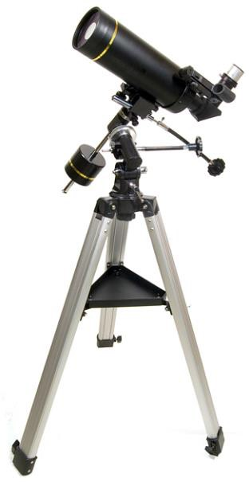
The Levenhuk Skyline PRO Telescopes are excellent choice for professionals and demanding observers. This series includes the variety of telescopes united by a common idea: "Maximum efficiency of observations and photography. Reliability. High-quality materials and optics".
Main Advantages:
- High-quality optics
- Reliable mounts and tripods
- Suitable for astrophotography
- Compactness and mobility
- Lifetime warranty

The series includes:
27646 Levenhuk Skyline PRO 90 MAK
30075 Levenhuk Skyline PRO 80 MAK
27647 Levenhuk Skyline PRO 105 MAK
28300 Levenhuk Skyline PRO 127 MAK

Levenhuk Telescopes Promotion | Levenhuk SkyMatic Series

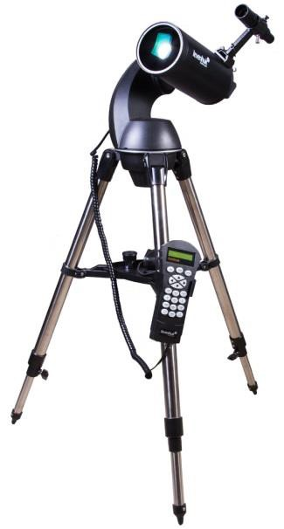
The Levenhuk SkyMatic telescopes feature auto-tracking, so they are suitable for beginners as well as experienced users. The pre-programmed database of the telescopes includes the data and coordinates of 42,000 celestial objects.

The telescopes provide automatic guidance to the selected star, planet or nebula. You operate the telescope with a hand controller. All objects are grouped into catalogs; you can also create your own object catalogs. The Levenhuk SkyMatic telescopes will allow you to make full use of a modern telescope, as they deliver views of striking quality.

Main Advantages:
    - High-quality optics
    - Reliable mounts and tripods
    - Highly precise auto-tracking system
    - Excellent choice for astrophotography
    - Compactness and mobility
    - Lifetime warranty

The series includes:
18116 Levenhuk SkyMatic 105 GT MAK
28296 Levenhuk SkyMatic 127 GT MAK
18114 Levenhuk SkyMatic 135 GTA

Levenhuk Microscopes Promotion | Entry-level Microscopes

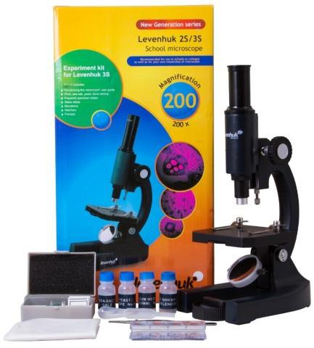
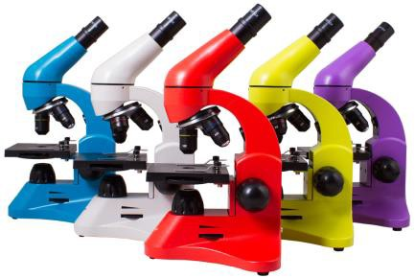
Entry-level Microscopes can be used by children and adults. Their magnification allows for studying microorganisms at the cellular level, such as infusoria. The microscopes feature upper illumination, which allows for viewing transparent specimens. These microscopes are excellent assistants to students in studies.
Entry-level models and series:
25648 Levenhuk 2S NG
66822 Levenhuk 3S (experiment kit included)
71917 Levenhuk 7S NG
Levenhuk Rainbow 2L (available in 5 vivid colors, experiment kit included)
Levenhuk Rainbow 2L PLUS
Levenhuk Rainbow 50L (available in 5 vivid colors, experiment kit included)
Levenhuk Rainbow 50L PLUS (available in 5 vivid colors, experiment kit included)

Main Advantages:
    - Good quality optics
    - Upper illumination
    - AC/batteries powered
    - Optimal price/quality ratio
    - Lifetime warranty

Target audience:
- Preschoolers and students
- The ones looking for a microscope as a gift
The Levenhuk Rainbow Microscopes - 2L, 2L PLUS, 50L and 50L PLUS. These original microscopes are available in 5 vivid colors!

The Levenhuk Rainbow series includes microscopes for education with up to 400x, 640x, 800x, 1280x magnification. Each model comes with the Levenhuk K50 Experiment Kit. You can choose the microscope body color and material: plastic or metal. The series includes optical and digital models.

Levenhuk Microscopes Promotion | Laboratory Microscopes

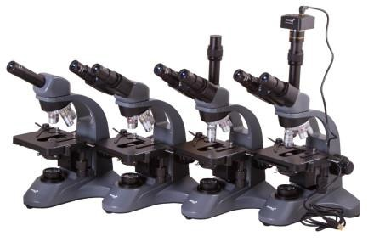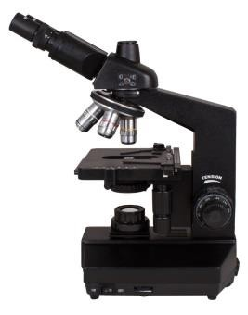
Laboratory Microscopes are generally used at higher educational and health institutions.
Due to fully multi-coated optics, you can study small cells, such as blood cells with high detail and at high magnification. This series includes monocular, binocular and trinocular microscopes. All models feature the Abbe condensers and high-quality optics.
Laboratory microscope models and series:
Levenhuk 320 BASE
Levenhuk 320 PLUS
Levenhuk 400, 500, 700, 800 and 900
Main Advantages:
- Superior quality optics
- Durable and reliable construction
- Wide range of visible objects
- Lifetime warranty
Target audience:
- Laboratory and medical institution workers, university professors
- Avid biology fans

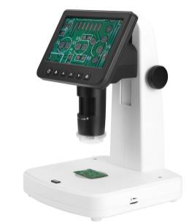
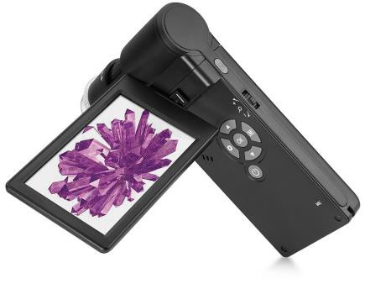
Levenhuk Microscopes Promotion | Digital Microscopes

Digital Microscopes are used for studying microcosm objects in detail or when you need extreme accuracy. You can study samples by viewing their digital images on a built-in or external monitor, and save the results of your work in the photo or video format to a micro SD card. With the Levenhuk digital microscope, it is convenient to perform technological operations, conduct laboratory research or study the microcosm.  Digital microscope models and series:  69065 Levenhuk Rainbow D2L 0.3M Digital Microscope, Moonstone (experiment kit included)  69081 Levenhuk Rainbow D2L 0.3M Digital Microscope, Moonstone (experiment kit included)  76826 Levenhuk Rainbow DM500 LCD  76825 Levenhuk Rainbow DM700 LCD 76827 Levenhuk LabZZ DM200 LCD  66826 Levenhuk D70L LCD(experiment kit included) 75433 Levenhuk D80L LCD  75434 Levenhuk D90L LCD 73812 Levenhuk D320L BASE 73796 Levenhuk D320L PLUS 75422 Levenhuk D400 LCD 70728 Levenhuk D740T  40030 Levenhuk D870T  Levenhuk DTX series Microscopes | 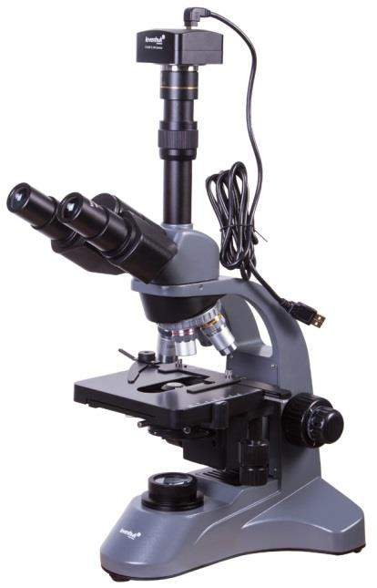
Main Advantages:
- The image is transmitted to the monitor promptly, with a minimum frame delay
- The price of the kit is less than the price of microscope and camera separately
- LCD models have built-in displays
- Durable and reliable constructions
- A wide range of applications
- Lifetime warranty
The Levenhuk DTX Microscopes are high-technology digital microscopes, designed for observing opaque samples and performing high-precision works. They use a digital camera for image capturing. The magnified image is displayed on the computer monitor or on the built-in LCD screen.
All microscopes are connected to a PC or laptop via USB cable. The models with the built-in screen can work fully autonomously.
The series includes:
61020 Levenhuk DTX 30
61021 Levenhuk DTX 50
61022 Levenhuk DTX 90
74768 Levenhuk DTX 350 LCD
61024 Levenhuk DTX 500 LCD
61023 Levenhuk DTX 500 Mobi
75075 Levenhuk DTX 700 LCD
75076 Levenhuk DTX 700 Mobi 70422 Levenhuk DTX TV 72474 Levenhuk DTX TV LCD 76824 Levenhuk DTX RC4 76823 Levenhuk DTX RC3 76822 Levenhuk DTX RC2 76821 Levenhuk DTX RC1

Main Advantages:
- Suitable for measuring the distance, square, angles, and radii of the observed objects
- White LEDs with adjustable brightness
- Capability to record videos and take pictures
- High-quality coating of the case allows for holding the microscope in hands with comfort
- Wide model range - magnification of 230x to 500x, with and without screen
- High-quality body and optics
- Easy to use and adjust, doesn't require any special skills
- Perfect choice for any field observations; for school and university students
- DTX RC models are remote controlled
Target audience:
- The ones looking for a universal microscope
- School and university students
- Various workshops and those who work with small details

Levenhuk Microscopes Promotion | Instrumental Microscopes
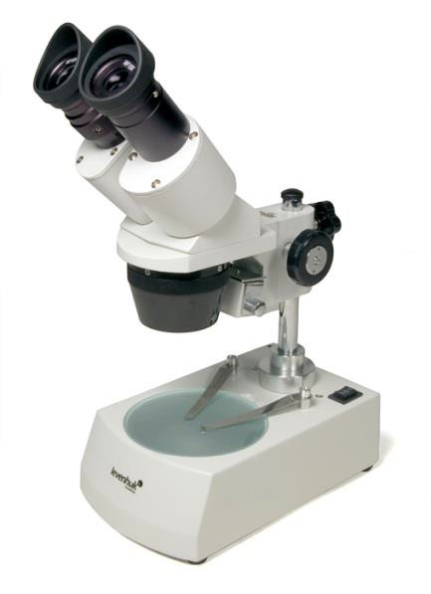
Levenhuk instrumental microscopes are perfect for work with specimens of any transparency degree. Any measurement works related to the microcosm are performed using instrumental microscopes. This is because they provide the three-dimensional image of the observed objects. The advantage of such models is that you can conduct observations under both the artificial and natural lighting.
The optical scheme is supplemented by a zoom objective, thanks to which you can change the magnification of the microscope not stepwise, but smoothly.
Main Features: high-contrast and the brightest image across the entire field of view, fully multi-coated optics. Fine adjustment to observer
Application: study of minerals, crystals, microchips and small clock mechanisms.
The series includes:
70404 Levenhuk 1ST
35322 Levenhuk 2ST
35323 Levenhuk 3ST
35321 Levenhuk 5ST 76057 Levenhuk ZOOM 1T 76056 Levenhuk ZOOM 1B

Main Advantages:
    - Superior quality optics
    - Durable and reliable construction
    - 3D image
    - Lifetime warranty

Levenhuk Microscopes Promotion | Digital Microscopes

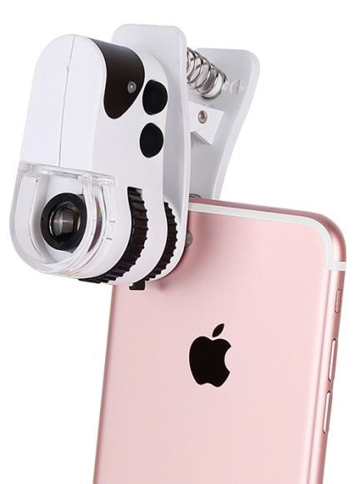
Levenhuk Zeno Cash series
Pocket microscopes
This series includes models with fixed or smooth variable magnification with one or several types of light; powered by batteries or an integral battery.
Main Features: some microscopes have clips for attaching a smartphone and an integral battery. They easily fit in a jacket pocket. Due to the built-in UV light, some microscopes can be used for paper currency verification.
The series includes:
74107 Levenhuk Zeno Cash ZC2
74108 Levenhuk Zeno Cash ZC4 74109 Levenhuk Zeno Cash ZC6 74110 Levenhuk Zeno Cash ZC7 74111 Levenhuk Zeno Cash ZC8
74112 Levenhuk Zeno Cash ZC10
74113 Levenhuk Zeno Cash ZC12 74114 Levenhuk Zeno Cash ZC14 74115 Levenhuk Zeno Cash ZC16
Main Advantages:
- Portable microscopes for paper currency verification and working with small items
- LED or UV lights
- Some microscopes have clips for attaching a smartphone.
- Some models are powered by an integral battery.
- Microscopes easily fit in a jacket pocket
- Lifetime warranty

Levenhuk Binoculars Promotion | Levenhuk Atom
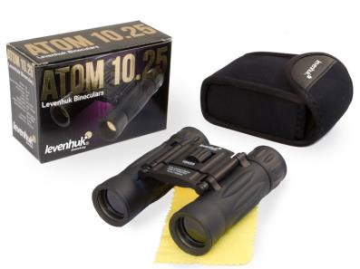
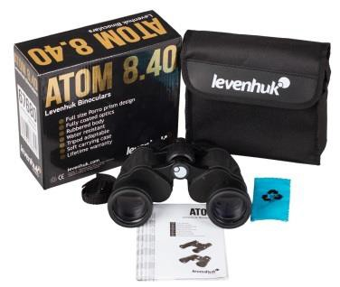
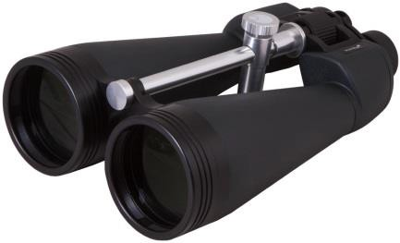

Levenhuk Atom Binoculars
Multipurpose optical devices with roof or Porro prisms can be used in any situation. They are best suited for outdoor use, both in the countryside and within the city. The optical elements made of high-quality glass BK-7 are fully coated. Some models have variable magnification.
The reliable rubberized shell securely protects the optics from moisture during observations, while a soft pouch included in the kit protects the binoculars during storage and transportation.
The series includes:

67675 Levenhuk Atom 8x21 74154 Levenhuk Atom 8x30 67680 Levenhuk Atom 8x40 67679 Levenhuk Atom 7x35 67681 Levenhuk Atom 7x50 67676 Levenhuk Atom 10x25 67677 Levenhuk Atom 12x25

Main Features:
67678 Levenhuk Atom 16x32 67682 Levenhuk Atom 10x50 67683 Levenhuk Atom 20x50 72517 Levenhuk Atom 7–21x40 71405 Levenhuk Atom 8–20x25 67684 Levenhuk Atom 10-30x50

    - An ergonomic rubber-armored shell provides for a secure, comfortable grip.
    - The binoculars body is lightweight, so they will easily fit in a backpack or a bag
    - High quality roof and Porro prisms allow everyone to choose binoculars to their liking.
    - Thanks to fully coated lenses, Levenhuk Atom Binoculars provide clear, sharp, exceptionally bright images.
    - The most affordable binoculars for any purposes
    - Good quality body and optics
    - Excellent choice for beginners or children

Target audience:
    - The ones looking for an affordable gift
    - Children
    - Travelers
    - The ones looking for amateur observation binoculars

Levenhuk Bruno PLUS Binoculars
Powerful, high-aperture binoculars for astronomical and stationary observations. Multi-element optics are effectively protected by a sealed body construction.
The series includes:
71146 Levenhuk Bruno PLUS 15x70 71147 Levenhuk Bruno PLUS 20x80

Main Features:
    - High-aperture objective lenses
    - Fully multi-coated lenses made of BaK-4 optical glass
    - Five-element eyepieces
    - Sealed waterproof shell is filled with nitrogen
    - Adaptability to tripods

Target audience:
    - Stationary observers
    - Novice astronomers
    - Travelers
Levenhuk Heritage Series is a joint project by the Levenhuk Company and the Russian Kazan Optical-Mechanical Plant
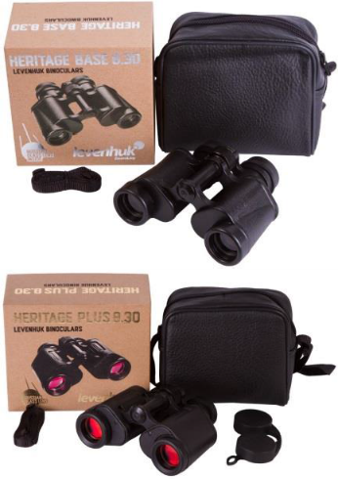
- Levenhuk Heritage BASE Series features durable metal bodies. These binoculars are made in Russia to the order from the Levenhuk Company. They feature lenses made of Russian BK10 glass coated with several layers of anti-reflective coating. Binoculars don't have reticle, so their price is lower than that of the Heritage PLUS Series.
- Levenhuk Heritage PLUS Series features optics with a special ruby coating. Due to their reticle, binoculars deliver a sharp and detailed image. They are also made in Russia to the order from the Levenhuk Company.
The series includes:
71390 Levenhuk Heritage BASE 8x30
71391 Levenhuk Heritage BASE 10x40
71392 Levenhuk Heritage BASE 12x45
71393 Levenhuk Heritage BASE 15x50
71394 Levenhuk Heritage PLUS 8x30
71396 Levenhuk Heritage PLUS 12x45

Main Features:
- Limited edition numbered series includes only 4,000 pieces, 3,000 of which were exported to the US and European countries.
- Made in Russia for Levenhuk, Inc. (USA)
- Optics made of Russian BK10 glass
- Fully multi-coated optics
- Robust aluminum body
- Wide operating temperature range
- The Heritage PLUS Series optics feature a reticle and a special ruby coating
Target audience:
- Older generation people, USSR optics amateurs
- Patriotic customers
- Extraordinary optics novelties amateurs
The Levenhuk Karma Binoculars and The Levenhuk Sherman Binoculars are base series including three lines each

The Levenhuk Karma Binoculars with the roof-prism design are great use for city observing or in a field situation. Wide field of view, enhanced optics, and ergonomic shell.
The Levenhuk Sherman Binoculars with the roof-prism design are classic field models. Wide field of view, high-quality optics, and waterproof nitrogen-filled shell.
Karma | Sherman
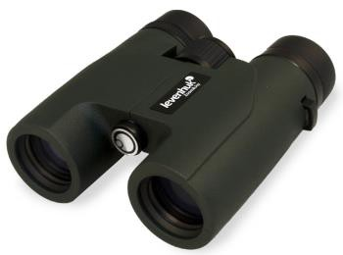 | 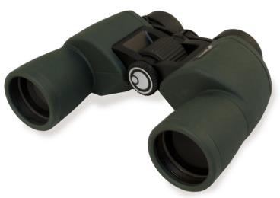
The Levenhuk Karma BASE Binoculars  - Compact roof-prisms  - Multi-coated lenses  The Levenhuk Karma PLUS Binoculars  - Compact roof-prisms  - Multi-coated lenses  - High-quality three-element eyepieces  - Waterproof shell  The Levenhuk Karma PRO Binoculars  - Compact roof-prisms  - Fully multi-coated optics  - Enhanced four-element eyepieces  - Wide field of view | The Levenhuk Sherman BASE Binoculars  - Porro-prisms  - Multi-coated lenses  - Waterproof shell  The Levenhuk Sherman PLUS Binoculars  - Porro-prisms  - Multi-coated lenses  - High-quality four-element eyepieces  - Wide field of view  - Waterproof shell  The Levenhuk Sherman PRO Binoculars  - Porro-prisms  - Multi-coated lenses  - Unique five-element eyepieces

- Waterproof shell | - Images without distortions  - Wide field of view  - Waterproof shell
How to shift from one line to another:
- The Karma PLUS Binoculars are the same as the Karma BASE Binoculars, but they are waterproof and feature the three-element eyepieces, which deliver a sharper image.
- The Karma PRO Binoculars are the same as The Karma PLUS Binoculars, but they feature the four-element eyepieces and multi-coated lenses.
- The Sherman PLUS Binoculars are the same as The Sherman BASE Binoculars, but they feature the four-element eyepieces and multi-coated lenses.
- The Sherman PRO Binoculars are the same as The Sherman PLUS Binoculars, but they feature the five-element eyepieces and multi-coated lenses.
The series includes: | The series includes:
74163 Levenhuk Karma BASE 8x32 74164 Levenhuk Karma BASE 8x42 74165 Levenhuk Karma BASE 10x32 74166 Levenhuk Karma BASE 10x42 67708 Levenhuk Karma PLUS 8x25 67707 Levenhuk Karma PLUS 8x32 67711 Levenhuk Karma PLUS 8x42 67706 Levenhuk Karma PLUS 10x25 67709 Levenhuk Karma PLUS 10x32 67710 Levenhuk Karma PLUS 12x32 67712 Levenhuk Karma PLUS 10x42 67713 Levenhuk Karma PLUS 12x42 67702 Levenhuk Karma PRO 8x25  67703 Levenhuk Karma PRO 8x32  67704 Levenhuk Karma PRO 8x42  67696 Levenhuk Karma PRO 10x25 67697 Levenhuk Karma PRO 10x32 67698 Levenhuk Karma PRO 10x42 67699 Levenhuk Karma PRO 10x50 67700 Levenhuk Karma PRO 12x50 67701 Levenhuk Karma PRO 16x42 | 71141 Levenhuk Sherman BASE 8x32 71142 Levenhuk Sherman BASE 8x42 71143 Levenhuk Sherman BASE 10x42 71144 Levenhuk Sherman BASE 10x50 71145 Levenhuk Sherman BASE 12x50 67730 Levenhuk Sherman PLUS 6,5x32 67729 Levenhuk Sherman PLUS 8x42 67733 Levenhuk Sherman PLUS 7x50 67731 Levenhuk Sherman PLUS 10x50 67732 Levenhuk Sherman PLUS 12x50 67723 Levenhuk Sherman PRO 6,5x32 67724 Levenhuk Sherman PRO 8x32  67725 Levenhuk Sherman PRO 8x42  67726 Levenhuk Sherman PRO 10x42 67727 Levenhuk Sherman PRO 10x50 67728 Levenhuk Sherman PRO 12x50
The Levenhuk Vegas ED and Monaco ED are the series of high-class optical instruments
The Levenhuk Vegas ED Binoculars and the Levenhuk Monaco ED Binoculars continue the legendary lines of Monaco and Vegas binoculars, which at one time were very popular among customers and proved themselves in sales. The new series promise to be no less popular among excellent optical instrument amateurs. These binoculars are perfect choice for a hunter, fishermen, wildlife observer, or anyone who enjoys active leisure, or needs binoculars for professional activities.
These binoculars come in original gift box. They are a great choice for a prestigious and expensive gift. They will please your loved one, colleague, or business partner. They feature a stylish design that can impress anyone.
Levenhuk Vegas ED Series | Levenhuk Monaco ED Series
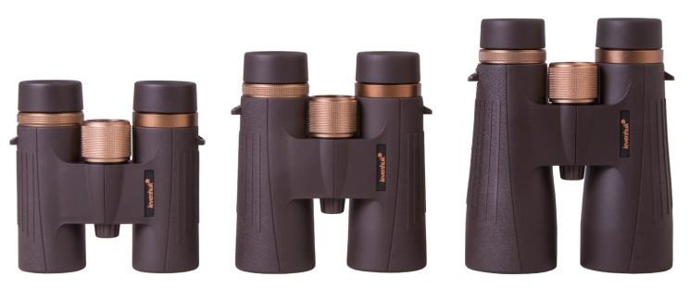  Dark-brown minimalist body design  copper color | 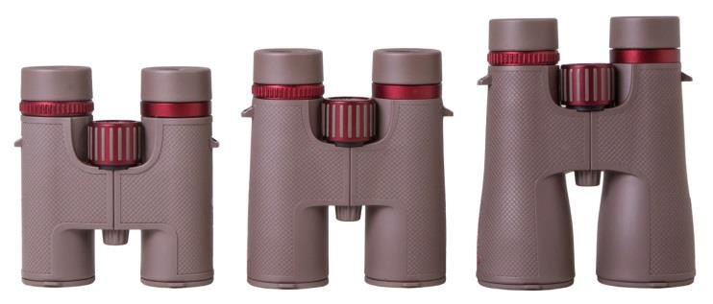  light-grey refined body design  deep red
Four-element eyepieces with a 23 mm diameter  Multi-element eyepieces deliver a high quality picture without optical aberrations. | Five-element eyepieces with a 28 mm diameter Improved eyepiece design allows you to see high-quality images, which means you get even more experience and see clearer!

Roof prism with phase correction coating  It provides precise color correction and maximum light transmission. | Roof prism with phase correction coating and dielectric lenses coating  This coating reduces internal light reflections and greatly enhances image brightness.
The series includes:  72814 Levenhuk Vegas ED 8x32 72815 Levenhuk Vegas ED 10x42  72816 Levenhuk Vegas ED 12x50 | The series includes:  72817 Levenhuk Monaco ED 8x32 72818 Levenhuk Monaco ED 10x42  72819 Levenhuk Monaco ED 12x50
What do both series have in common?
- Extra-low dispersion optics. ED glass removes color distortions in the picture, such as rainbow halos around objects. This effect is due to light scattering and can often be seen in budget binoculars.
- Modern roof-prisms. They transmit sharp and detailed images. Compared to Porro-prism binoculars, the roof-prism models are significantly smaller and lighter.
- Fully multi-coated optics. All optical elements are coated with several layers of a special coating, which makes the image in brighter. You can observe even at dusk.
- Suitable for work in extreme conditions. Waterproof design: if you drop the binoculars into a river or a lake, they will be safe for three minutes. The binoculars’s shell is filled with nitrogen that protects the lenses from condensed water and prevents the objective lenses and eyepieces from fogging.
- Neck strap (45mm wide). It puts less pressure on the neck compared to standard narrow belts. Even a long walk with heavy binoculars will not be hard.
- The kit includes a rigid zip case for storing and transporting. The case does not deform from light blows, it is convenient to open it with one hand.
- Adaptable to a tripod. Binoculars mounted on a tripod provide better image stabilization.

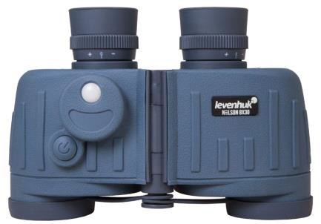
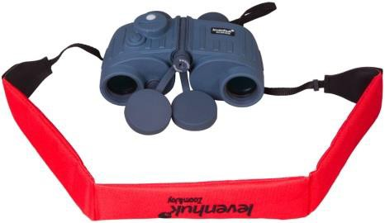
Levenhuk Nelson series of floating marine binoculars
Durable embossed shell protects the optics from moisture and accidental hits, so they are great choice for fishermen and water activity enthusiasts. The optical scheme uses Porro prisms. The quality optics are made of BaK-4 glass. The device features multi-coated lenses. The waterproof shell is made of durable plastic and is rubberized. You can install these best marine binoculars on a tripod. There is a special tripod socket on the binoculars’ body.

The Levenhuk Nelson optical tools are equipped with a built-in rangefinder and a compass with LED light. The eyepieces feature the instrument scales.
    - The compass indicates the direction towards the object. Division value is 1°. North is 360°, South is 180°, East is 90° and West is 270°. You need two batteries to power LED light.
    - The rangefinder serves for calculating the distance to the observed object or its size. You need to know one of these parameters to calculate another one, using a special formula.

When selling these binoculars, do not forget to propose a bright Levenhuk FS10 Floating Strap (product ID: 71148). If your camera or binoculars accidentally drop into a river or lake, this strap will not let them sink.

The series includes:
72108 Levenhuk Nelson 8x30 72109 Levenhuk Nelson 7x50

Target audience:
    - People, who like to observe on the water and near water bodies.
    - Guards and hunters
    - Yacht and boat owners

Levenhuk Broadway Opera Glasses
Compact, lightweight, luxury, they are not only a practical tool, but a stylish accessory as well. The optical elements are made of fully multi-coated BaK-4 glass and create bright, vivid images. All models feature a wide field of view.
They are manufactured in four modifications:
- Levenhuk Broadway 325C series - with a thin metal chain and without LED light.
- Levenhuk Broadway 325F series - with a thin metal chain and LED light.
- Levenhuk Broadway 325L Opera Glasses - theater binoculars-lorgnettes without LED light.
- Levenhuk Broadway 325N series – theater binoculars- with LED light.
These binoculars are very compact and fit easily into a purse or pocket. They are excellent choice for theater amateurs as well as a great gift.
Levenhuk Broadway 325C | Levenhuk Broadway 325C
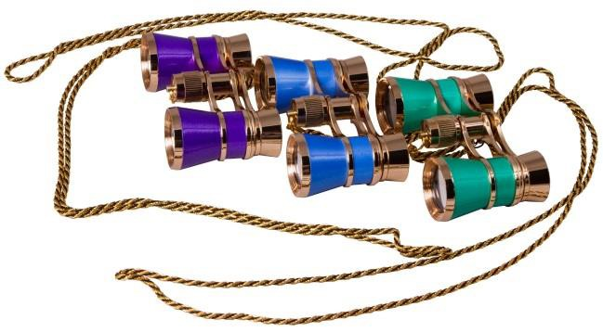 | 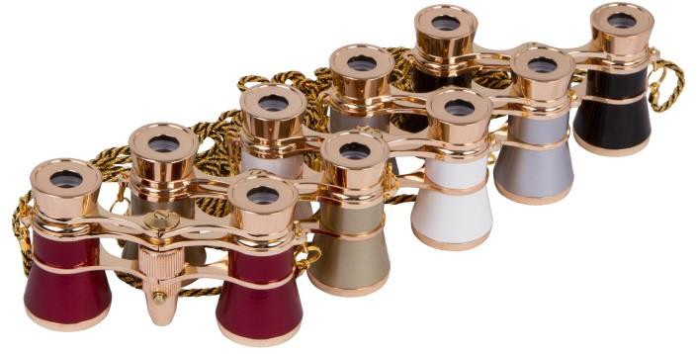
The series includes:  70870 Levenhuk Broadway 325C Amethyst 70871 Levenhuk Broadway 325C Blue Wave 70872 Levenhuk Broadway 325C Lime | The series includes:  28817 Levenhuk Broadway 325F, White  28818 Levenhuk Broadway 325F, Gold  17782 Levenhuk Broadway 325F, Red  17781 Levenhuk Broadway 325F, Silver  17783 Levenhuk Broadway 325F, Black
Levenhuk Broadway 325L | Levenhuk Broadway 325N
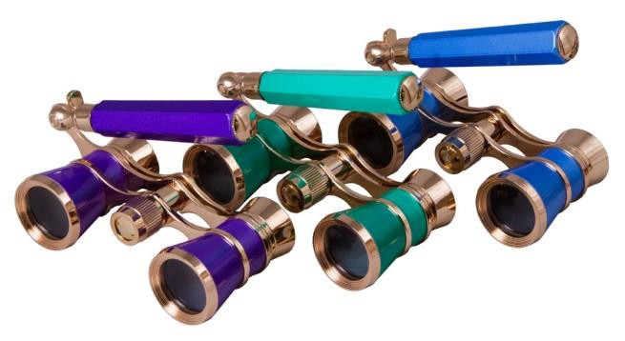 | 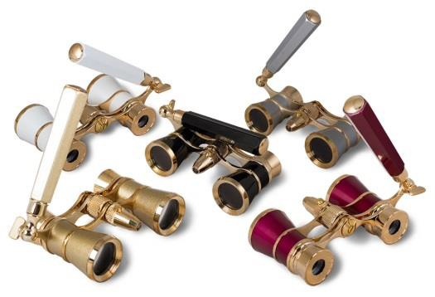
The series includes:  70873 Levenhuk Broadway 325L, Amethyst 70874 Levenhuk Broadway 325L, Blue Wave 70875 Levenhuk Broadway 325L, Lime | The series includes:  17785 Levenhuk Broadway 325N, White  28821 Levenhuk Broadway 325N, Gold  28820 Levenhuk Broadway 325N, Red  28822 Levenhuk Broadway 325N, Silver  17784 Levenhuk Broadway 325N, Black

Levenhuk Spotting Scopes Promotion | Series

High quality and reliable Levenhuk spotting scopes are the perfect choice for observing significantly distant objects. These spotting scopes with relatively small objective lenses and low weight are great for hiking and traveling. Spotting scopes with powerful large aperture objectives can be successfully used for hunting and professional use.
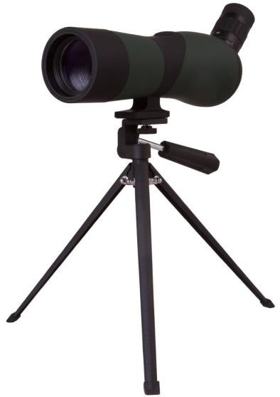
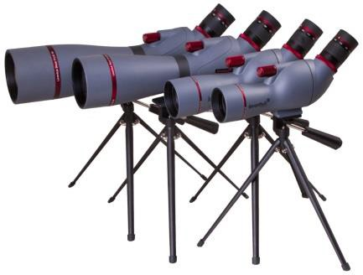
All scopes are equipped with high-quality fully coated optics, which provide clear and bright images. Levenhuk spotting scopes are waterproof and allow you to observe under any weather conditions.

Levenhuk Blaze Spotting Scopes
These models are excellent for extended stationary observations of wildlife or any sports competitions.
    - The "younger" models of the series feature the fixed magnification and wide field of view (they have the letter F in the name)
    - The "senior" models of the series feature the smooth variable magnification, high aperture and impressive power.
The optics are made of BK-7 glass, and both lenses and prisms are fully coated. The spotting scopes come with stable metal tripods.
The series includes:
72094 Levenhuk Blaze BASE 50F 72095 Levenhuk Blaze BASE 60F 72096 Levenhuk Blaze BASE 50
72097 Levenhuk Blaze BASE 60
72098 Levenhuk Blaze BASE 70
73900 Levenhuk Blaze BASE 80
73901 Levenhuk Blaze BASE 100

Main Features:
      - Angled eyepiece
      - Variable or constant magnification
      - Fully coated glass optics
      - Durable design
      - Case and tripod in the kit

Target audience:
      - The ones looking for an affordable gift
      - Children
      - Travelers
      - The ones looking for simple instrument for observing

Levenhuk Blaze PLUS Spotting Scopes
The PLUS series models differ from the previous the Levenhuk Blaze BASE series, first, in improved optics and design.
The fully multi-coated optics are made of BK-7 glass.
Each model features a removable metal eyepiece. Therefore, the optics transmit a vivid and detailed image with correct color rendition.
The series includes:
72099 Levenhuk Blaze PLUS 50
72100 Levenhuk Blaze PLUS 60
72101 Levenhuk Blaze PLUS 80
72102 Levenhuk Blaze PLUS 90

Main Features:
      - Angled eyepiece
      - Variable magnification, wide range of magnification
      - Large-aperture objective can be used at dusk
      - Waterproof and nitrogen-filled shell
      - Removable eyepiece

Target audience:
      - Tourists
      - Fishermen
      - Hunters

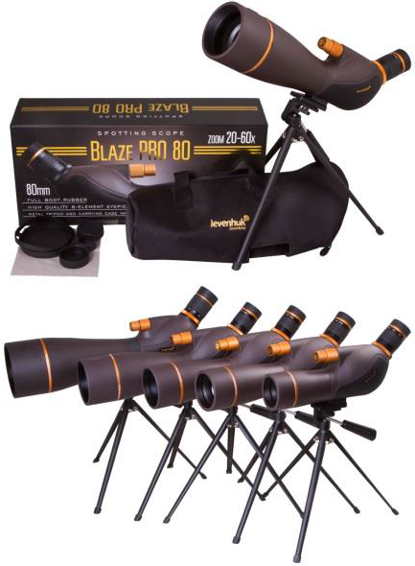
Levenhuk Blaze PRO Spotting Scopes
These models are an excellent choice for those, who are looking for a reliable optical instrument for observations in any conditions. Their objective lenses gather enough light to transmit a crisp and clear image even at dusk or dawn.
Main Features: Variable magnification, fully multi-coated optics made of BK-7 glass, hermetic shell with nitrogen filling, removable metal eyepiece, and metal table tripod in the kit.
The series includes:
72103 Levenhuk Blaze PRO 50
72104 Levenhuk Blaze PRO 60
72105 Levenhuk Blaze PRO 70
72106 Levenhuk Blaze PRO 80
72107 Levenhuk Blaze PRO 100
Key selling phrases:
- High-quality optics transmit sharp contrast images.
- The waterproof shell with a nitrogen filling securely prevents the lenses from fogging during abrupt temperature changes.
- The kit includes a small tabletop tripod necessary for observing at high magnification: it minimizes the image trembling.
Target audience: experienced users
Levenhuk Blaze Digital Spotting Scopes
These models are modern optical devices with a built-in digital camera. They provide fixed or variable magnification, display the picture on the built-in or external screen and allow for taking photos and recording videos.
They are perfect for birdwatching, observing wildlife, and landscapes.
The series includes:  73344 Levenhuk Blaze D500 73810 Levenhuk Blaze D200 | Target audience:  - Wildlife photographers, natural scientists, ornithologists.  - Tourists, outdoor activities amateurs and hikers
Levenhuk Blaze D500 Spotting Scope | Levenhuk Blaze D200 Spotting Scope
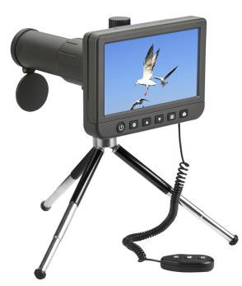 | 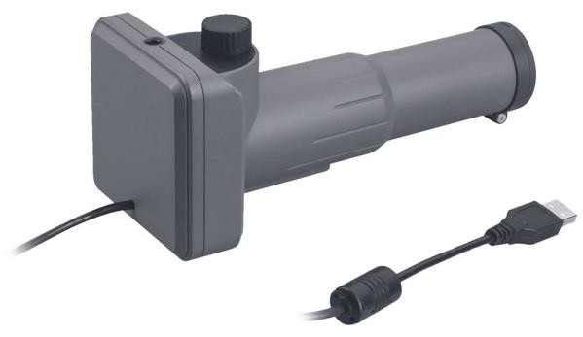
Main Features:  - Perfect for birdwatching, observing wildlife, and landscapes.  - Built-in digital camera with 50x magnification  - Manual focusing for the most precise and smooth adjustment of sharpness  - Metal tripod and remote control included  - 5'' color LCD screen  - Images: *.jpeg, 5MP, 8MP, 10MP, 12MP, 14MP  - Video: *.mp4, 1080P, 720P  - Connect to projector, TV/computer screen | Main Features:  - 20x magnification  - Built-in 2MP digital camera, suitable for recording videos in 1080p resolution  - Can be connected to a computer, smartphone, or tablet, due to this feature, it doesn't need its own screen, so its price is lower  - Compatible with Windows, Mac and Android OS, OTG cable with a micro USB connector included  - Metal tripod included

Levenhuk Blaze Compact Series
These models are impervious to any weather conditions and feature the smooth variable magnification. They are adaptable to a tripod.
It is an excellent choice for customers who have an active lifestyle, enjoy hiking and exploring the world around them, as well as hikers, birdwatchers, naturalists, hunters and fishermen.
Levenhuk Blaze Compact Spotting Scopes  The series of ultra-compact spotting scopes with the smooth variable magnification. The optical elements are made of the fully multi-coated BK-7 glass. | Levenhuk Blaze Compact ED Spotting Scopes  They feature the ultra-compact body. Their high-quality fully multi-coated optics is made of extra-low dispersion ED glass.
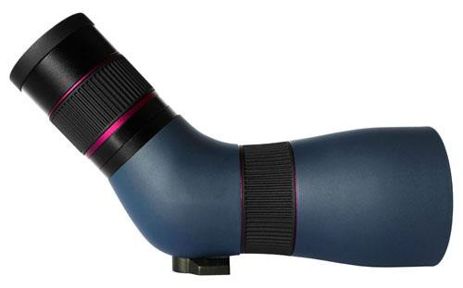  The models of the series are easily recognizable by the purple stripes on the shell | 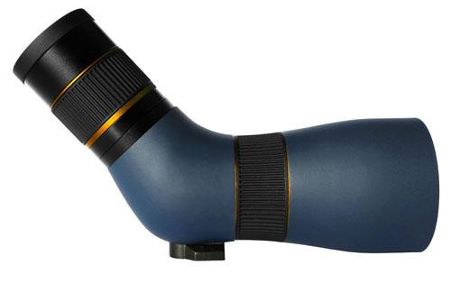  The distinctive design element is golden  stripes on the shell
The series includes:  74159 Levenhuk Blaze Compact 50  74160 Levenhuk Blaze Compact 60 | The series includes:  74161 Levenhuk Blaze Compact 50 ED  74162 Levenhuk Blaze Compact 60 ED
What do both series have in common?
- Six-element angled removable eyepiece for more natural color rendering, and a brighter image
- Smooth variable magnification: 8–24x (Blaze Compact 50/50 ED), 9–27x (Blaze Compact 60/60 ED)
- Close focus: 1.5 m (Blaze Compact 50/50 ED), 2 m (Blaze Compact 60/60 ED)
- Nitrogen filling
- Waterproof shell

Adaptability to tripods
- Pouch for transportation and storage

Levenhuk Monoculars Promotion | Series
Monoculars are a great alternative to binoculars. These are robust, convenient and compact optical tools with high-quality optics. Their image quality is the same as that of binoculars. They are also lightweight and compact, so they can come in handy in a variety of situations: on a walk, hike, trip, and hunting.
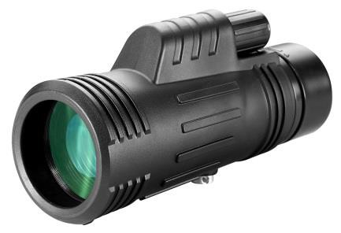
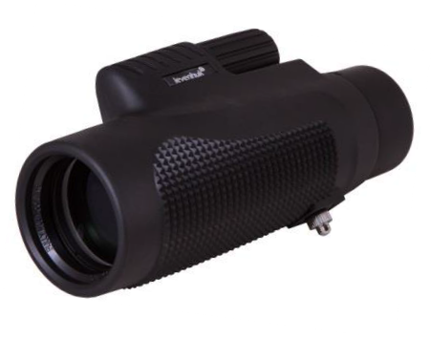
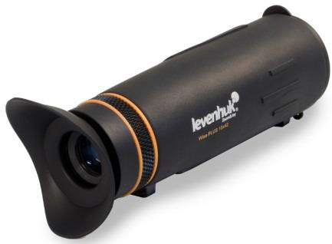

Levenhuk Atom Monoculars
These entry-level monoculars feature a waterproof shell. Their optics are made of BK-7 glass. These monoculars do not feature sealed shell, therefore they are budget friendly.
The series includes:
74094 Levenhuk Atom 8x42 74095 Levenhuk Atom 10x42 74096 Levenhuk Atom 10–30х30

Main Features:
    - Budget friendly and low-maintenance
    - Multi-coated optics
    - Adaptability to tripods
    - Lightweight and compact
    - Some models have variable magnification.

Levenhuk Wise Monoculars

Target audience:
    - Hikers, ornithologists
    - Children
    - Long walk amateurs
    - The ones finding binoculars too sizable

One more base monoculars series. The optics of Levenhuk Wise are made of fully multi-coated BaK-4 glass, but they are not waterproof.
The series includes:
69684 Levenhuk Wise 8x32 69685 Levenhuk Wise 8x42 69686 Levenhuk Wise 10x42 71404 Levenhuk Wise 8–24x50

Main Features:
    - Universal monoculars
    - Optics made of BaK-4 optical glass
    - Fully multi-coated lenses
    - Adaptability to tripods
    - Lightweight and compact
    - Some models have variable magnification.

Levenhuk Wise PLUS Monoculars

Target audience:
    - The same as the Atom series, but much more demanding about the image quality.

This is a series of monoculars with stylish, streamline shaped shells. Their optics are made of BaK-4 optical glass. They are waterproof and impervious to all weather conditions. A convenient detachable strap that easily adjusts to fit your hand and a removable rubber eyecup are included.
The series includes:
67738 Levenhuk Wise PLUS 8x32 67739 Levenhuk Wise PLUS 8x42 67740 Levenhuk Wise PLUS 10x42

Main Features:
    - A waterproof and shockproof shell is filled with nitrogen
    - The optics are made of fully multi-coated BaK-4 glass
    - Removable rubber eyecups
    - Adjustable to a tripod
    - Convenient detachable strap
    - Rubber-armored shell for a secure grip

Target audience:
    - Tourists
    - Fishermen
    - Hunters
    - Those who want to always have an optical instrument at hand

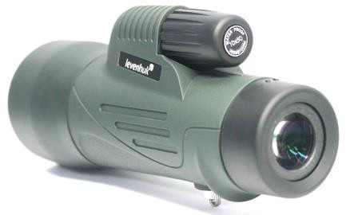
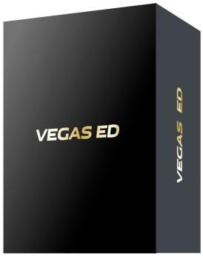
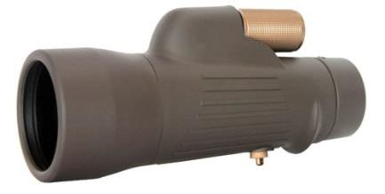
Levenhuk Wise PRO Monoculars
The series of sealed monoculars with a wide field of view. Their aperture is powerful enough for observing in low light conditions. Multi-coated optics made of high quality BaK-4 glass.
The series includes:
74155 Levenhuk Wise PRO 8x42 74156 Levenhuk Wise PRO 10x50

Main Features:
    - Multi-coated optics made of BaK-4 glass.
    - Adaptability to tripods
    - IPx7 waterproof (It will not be damaged from falling in a pond or lake)
    - Nitrogen-filled shell (It protects the optical elements from fogging)
    - Long eye relief (It allows for observing in either regular glasses or sunglasses)

Differences from Levenhuk Wise and Wise PLUS series:
Target audience:
    - Those who choose a quality monocular for any weather conditions

    - The field of view of optics has become wider by 19% - for the Wise PRO 8x42 it is 131 meters
    - Close focusing distance is 2 meters - you can study not only distant, but also close objects
    - The new high-aperture model is the Wise PRO 10x50 Monocular

Levenhuk Vegas ED Monoculars
High-class monoculars.
This is a series of monoculars with the lenses made of extra-low dispersion glass, so these optical instruments deliver a clear and detailed image.
The series includes:
74157 Levenhuk Vegas ED 8x42 74158 Levenhuk Vegas ED 10x50

Why are customers willing to pay for ED optics?
    - Clear and detailed image
    - Absence of chromatic aberrations across the entire field of view
    - Designed for professional use

Main Features:
    - Fully multi-coated optics made of ED glass
    - Waterproof and nitrogen-filled shell
    - Adaptability to tripods
    - Long eye relief (It allows for observing in either regular glasses or sunglasses)
    - IPx7 waterproof (It will not be damaged from falling in a pond or lake)

Target audience:
    - Demanding customers
    - Professional observers
    - People who choose an expensive but compact optical instrument as a gift

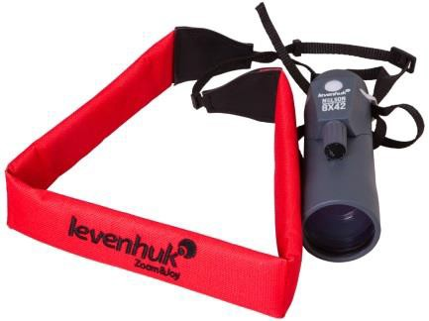
Levenhuk Nelson Series

These sealed marine monoculars are designed for fans of water tours and fishing. The optical elements are made of BaK-4 glass, which ensures the high image quality. Multi-coated lenses transmit a bright and detailed picture. A wide field of view allows for comfortable observations of the skyline. A special feature of the Nelson series is the built-in rangefinder and compass. You will not only perform observations, but also measure the distance to objects and determine their precise location.
The series includes:
72110 Levenhuk Nelson 7x35 72111 Levenhuk Nelson 8x42

When selling these binoculars, do not forget to offer a bright Levenhuk FS10 Floating Strap (product ID: 71148). If your binoculars or your camera is accidentally dropped into a river or lake, this strap will not let them sink.

Main Features:
    - Classic marine monocular with a built-in compass and a rangefinder
    - Waterproof nitrogen-filled shell (IPX7 waterproof-rated protection)
    - Optics made of BaK-4
    - Fully multi-coated optics
    - A wide field of view

Target audience:
    - People, who like to observe on and close to the water.
    - Guards and hunters
    - Yacht and boat owners

Levenhuk Rainbow Monoculars
These are lightweight and compact models with a wide field of view and 8x magnification. They feature fully multi-coated optics and bright-colored bodies
The series includes:
72595 Levenhuk Rainbow 8x25 Red Berry 72596 Levenhuk Rainbow 8x25 Sunny Orange 72597 Levenhuk Rainbow 8x25 Lime
72598 Levenhuk Rainbow 8x25 Blue Wave 72599 Levenhuk Rainbow 8x25 Amethyst

Main Features:
    - Five bright colors
    - Compact size and small weight
    - The multi-coated optics are made of BK-7 glass
    - Wide field of view
    - User-friendly design

Target audience:
    - Parents looking for an optical device for their child
    - The ones looking for an unusual affordable gift
    - Long walk amateurs

Levenhuk Cameras Promotion | Series

Levenhuk produces digital cameras for microscopes and telescopes.

    - The Levenhuk digital cameras are very durable, because they feature a metal casing. The cameras transfer the image with minimum frame delay.
    - Installation CD with Levenhuk image editing software is included. The program is simple, easy to use, and compatible with modern OS.
    - A wide range of models is able to satisfy both novice users and professionals.
    - All cameras allows for taking pictures and recording videos.
    - The cameras come with a lifetime warranty.
    - System requirements: Windows XP (32-bit), Windows Vista/7/8/10 (32-bit or 64-bit), Mac OS X, Linux, CPU IntelCore 2 or above; RAM 2GB, USB port 2.0, CD-ROM.

Levenhuk Microscope Cameras

These cameras can be placed in the eyepiece tube instead of the eyepiece in monocular and binocular models, or into the third tube of trinocular models.
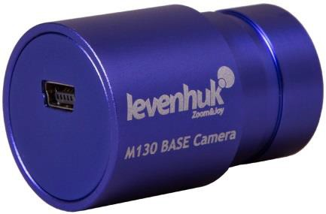
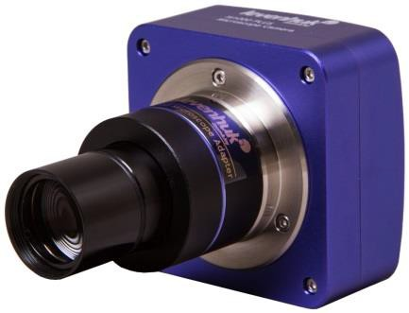

Levenhuk M BASE Microscope Cameras
These models are a perfect choice if you are just thinking about getting into
microphotography.
The range includes a variety of models from 0.3 to 5 megapixels that allow you to take pictures and record videos of your research. The cameras are compatible with biological and stereoscopic microscopes.
The series includes:
70352 Levenhuk M035 BASE 70353 Levenhuk M130 BASE 70354 Levenhuk M200 BASE 70355 Levenhuk M300 BASE 70356 Levenhuk M500 BASE

Main Features:
    - Compatible with microscopes of 23.2-mm eyepiece tube diameter
    - Metal body in a beautiful deep purple color
    - Can be used for teaching or scientific hobbies
    - Can take clear images of large objects as well as tiny cells
    - Charging and connecting to a PC via a USB port

Levenhuk M PLUS Series
These models are suitable for professional activities. The camera transmits a sharp, high-contrast image. The cameras range from 8 to 14 megapixels and allow you to take pictures and record videos of observed objects. The kit includes adapters for eyepiece tubes of different diameters. The cameras can be installed on biological and stereoscopic microscopes.
The series includes:
70357 Levenhuk M800 PLUS 70358 Levenhuk M1000 PLUS 70359 Levenhuk M1400 PLUS

Main Features:
    - Compatible with eyepiece tubes of different barrel diameters (23.2–30mm and 23.2–30.5mm)
    - Digital cameras series with a high resolution
    - Metal body in a beautiful deep purple color
    - Excellent choice for professionals
    - Can take clear images of large objects as well as tiny cells
    - Charging and connecting to a PC via a USB port

Compatibility of Levenhuk microscopes with Levenhuk digital cameras

Microscope series | Compatible with Levenhuk cameras | Camera adapter required | Eyepiece tube diameter, mm | Comments
1ST | yes | no | 23.2 | –
2ST, 3ST, 5ST | yes | yes, 23.2–30.5mm  (better option)  or 23.2–30mm | 30.5 | 2ST, 3ST: first, unscrew the eyepiece with a Phillips screwdriver;5ST: simply remove the eyepiece
2L / 2L PLUS | yes | no | 23.2 | –
50L / 50L PLUS | yes | no | 23.2 | –
320 BASE / PLUS | yes | no | 23.2 | –
400 (400M, 400B,  400T) | yes | no | 23.2 | trinocular models allow you to install a camera instead of an eyepiece in the third tube of the trinocular head as well (the tube is equipped with a proper adapter)
400 (D400 LCD) | no  built-in digital camera; installation of external camera is not applicable
500 (500M, 500B,  500T, 500T POL) | yes | no | 23.2 | trinocular models allow you to install a camera instead of an eyepiece in the third tube of the trinocular head as well (the tube is equipped with a proper adapter)
600 (625, 670T, D670T) | yes | no | 23.2 | trinocular models allow you to install a camera instead of an eyepiece in the third tube of the trinocular head as well (the tube is equipped with a proper adapter)
700 (700M, 720B,  740T, D740T) | yes | no | 23.2 | trinocular models allow you to install a camera instead of an eyepiece in the third tube of the trinocular head as well (the tube is equipped with a proper adapter)
800 (850B, 870T, D870T) | yes | no | 23.2 | trinocular models allow you to install a camera instead of an eyepiece in the third tube of the trinocular head as well (the tube is equipped with a proper adapter)
900 (900B, 900T,  950T DARK) | yes | no | 23.2 | trinocular models allow you to install a camera instead of an eyepiece in the third tube of the trinocular head as well (the tube is equipped with a proper adapter)
D70L | yes | no | 23.2 | to install a camera, remove the display module
D80L LCD, D90L LCD | no  built-in digital camera; installation of external camera is not applicable
DTX | no  built-in digital camera; installation of external camera is not applicable
S NG | yes | no | 23.2 | –
LabZZ M1, M2, M3 | no  17-mm eyepiece tube diameter is not compatible with Levenhuk digital cameras
LabZZ M4 | yes | no | 23.2 | –
LabZZ M101 | no  installation of external digital camera is not supported due to non-removable eyepiece
Zeno Cash | no  installation of an external digital camera is not applicable (there is no eyepiece tube)
ZOOM (1B, 1T) | yes | yes, 23.2–30mm | 30 | trinocular models allow you to install a camera instead of an eyepiece in the third tube of the trinocular head as well (the tube is equipped with a proper adapter)

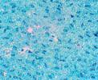
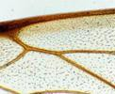
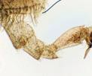
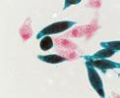
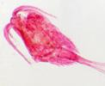
Microscope Slides
The images made with the Levenhuk Rainbow 50L Microscope

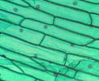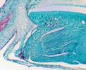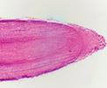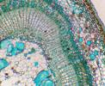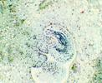

Onion peel, 150x | Wheat weevil, 60x | Root cap, 60x | Lime twig, 60x | Anther, 60x | Plant ovary, 60x
Geranium leaf epidermis, 60x | Geranium leaf epidermis, 150x | Bee wing, 60x | Bee limb, 60x | Euglena, 600x | Cyclops, 60x

Levenhuk Telescope Cameras

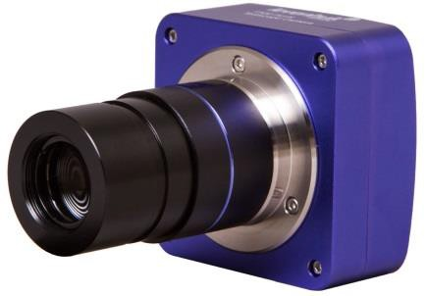
Levenhuk T PLUS cameras for telescopes
These models can significantly expand the capabilities of your telescope. The cameras are compatible with any modern refractors, reflectors and catadioptric telescopes. The camera is installed directly into the focuser of the telescope. It transfers the image from the telescope to a computer screen in real time. It allows you to save pictures and videos. There are cameras from 1.3 to 8 megapixels in the range of models.
The series includes:
70360 Levenhuk T130 PLUS 70361 Levenhuk T300 PLUS 70362 Levenhuk T500 PLUS 70363 Levenhuk T800 PLUS
Main Features:
- Adapter (31.75mm / 1.25'') in the kit
- Metal body in a beautiful deep purple color
- Charging and connecting to a PC via a USB port

Levenhuk T130 PLUS Digital Camera  This camera allows for getting high-quality images of the Moon and planets of the Solar System.  - Maximum resolution: 1280x1024  - Megapixels: 1.3 | Levenhuk T300 PLUS Digital Camera  This camera is suitable for observing the Moon, Saturn (with rings), Jupiter (with moons), as well as nearby nebulae such as the Orion Nebula.  - Maximum resolution: 2048x1536  - Megapixels: 3
Levenhuk T500 PLUS Digital Camera  This camera allows for observing objects of the solar system as well as deep sky objects in all their glory.  - Maximum resolution: 2592x1944  - Megapixels: 5 | Levenhuk T800 PLUS Digital Camera  This camera is a great choice for experienced astrophotographers. You can watch the night sky and large astronomical objects in incredible detail.  - Maximum resolution: 3264x2448  - Megapixels: 8

Space objects photos taken with the Levenhuk SkyMatic telescopes

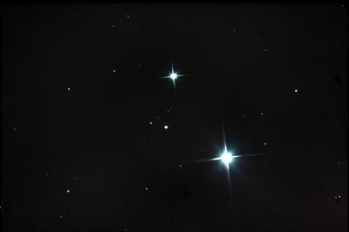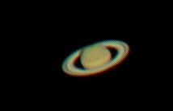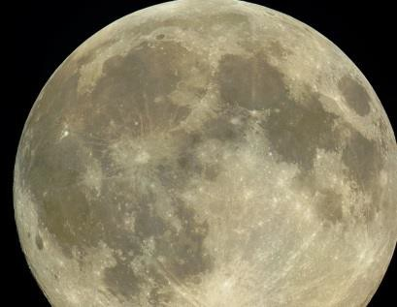
Mizar and Alcor Stars Saturn The Moon

Levenhuk Magnifiers Promotion | series

Levenhuk Magnifiers are reliable optical instruments for domestic and professional use. Levenhuk magnifiers are reliable and durable due to the highest quality materials of all components. Lenses are made of highly transparent glass or special optical plastic. Most of the models are equipped with LED illumination so that, you can use them in low light conditions.

Magnifiers are some of the most top-selling items. They are easy to sell. Not only vision impaired use them, many people use them for reading, for examining small images and models, for needlework, for mechanical or electronic work.

All the Levenhuk magnifiers carry a manufacturer's lifetime warranty and come in a gift package.

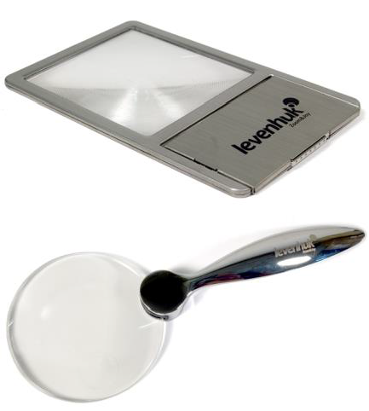
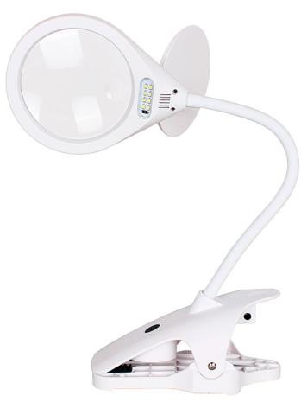
Levenhuk Zeno
These are universal magnifiers for working with small fonts and images.
The series includes:
38114 Levenhuk Zeno 50, 2,2/4,4x, 88/21mm, 2 LED
38115 Levenhuk Zeno 60, 2,5/5x, 88/21 mm, 2 LED
38122 Levenhuk Zeno 90, 2,5x, 48x45mm, 1 LED, Metal 38121 Levenhuk Zeno 100, 2,5/5x, 78/19 mm, Metal
38118 Levenhuk Zeno 400, 2/4x, 88/21 mm, 2 LED, Metal 38116 Levenhuk Zeno 500, 3,5x, 56 mm, 8 LED, Metal
38117 Levenhuk Zeno 600, 2,5x/5x, 90/21 mm, 12 LED, Metal
38120 Levenhuk Zeno 700, 10x, 30 mm, 3 LED, Metal
69202 Levenhuk Zeno 900, 5x, 75 mm, 3 LED, Metal
38119 Levenhuk Zeno 1000, 2,5/5x, 88/21 mm, 2 LED

Main Features:
    - Universal magnifiers for working with small fonts and images
    - Desktop models and magnifiers with handles
    - Metal or plastic handles
    - Majority feature two different magnification lenses (bifocal)
    - LED light (except Zeno 100)

Levenhuk Zeno Desk
These are desktop magnifiers for a longtime work with small objects. The distinguishing features of these models are bifocal lenses, built-in illumination and “third hand” holders.

The series includes:
71205 Levenhuk Zeno Desk D0 70440 Levenhuk Zeno Desk D1 70441 Levenhuk Zeno Desk D3 70442 Levenhuk Zeno Desk D5 70443 Levenhuk Zeno Desk D7 70444 Levenhuk Zeno Desk D9

70445 Levenhuk Zeno Desk D11 70446 Levenhuk Zeno Desk D13 74103 Levenhuk Zeno Desk D15 74104 Levenhuk Zeno Desk D17 74105 Levenhuk Zeno Desk D19

Main Features:
    - The majority of models feature two different magnification (bifocal) lenses
    - Zeno Desk D0 features measuring scale
    - The lens is fixed firmly on the mount, leaving both hands free.
    - The LEDs are powered by batteries or AC
    - You can adjust the lens inclination angle according to your needs

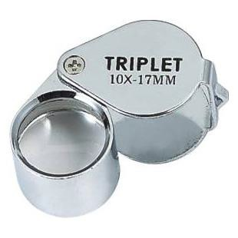
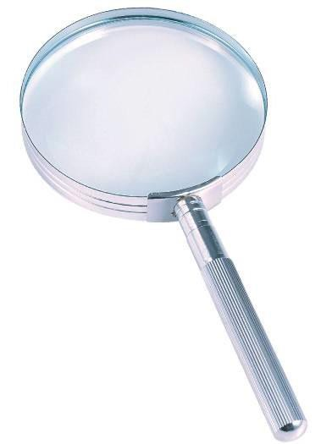
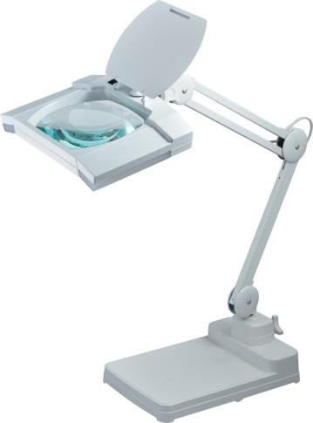
Levenhuk Zeno Gem
These are magnifiers for jewelers or anyone who works with small objects. Several models have a built-in illumination and a folding construction.
The series includes:
70434 Levenhuk Zeno Gem M1 70435 Levenhuk Zeno Gem M3 70436 Levenhuk Zeno Gem M5 70437 Levenhuk Zeno Gem M7 70438 Levenhuk Zeno Gem M9

Main Features:

70439 Levenhuk Zeno Gem M13 70517 Levenhuk Zeno Gem M11 74041 Levenhuk Zeno Gem ZM5 74042 Levenhuk Zeno Gem ZM7 74043 Levenhuk Zeno Gem ZM9 74044 Levenhuk Zeno Gem ZM11

    - Designed especially for jewelers and watchmakers
    - There are models with glass optics and high magnification
    - Compact folding construction

Levenhuk Zeno Handy
These are handheld viewing magnifiers of different diameters and magnifications.

The series includes:
74045 Levenhuk Zeno Handy ZH3 74046 Levenhuk Zeno Handy ZH5 74047 Levenhuk Zeno Handy ZH7 74048 Levenhuk Zeno Handy ZH9 74049 Levenhuk Zeno Handy ZH11 74050 Levenhuk Zeno Handy ZH13 74051 Levenhuk Zeno Handy ZH15 74052 Levenhuk Zeno Handy ZH17 74053 Levenhuk Zeno Handy ZH19 74054 Levenhuk Zeno Handy ZH21

74055 Levenhuk Zeno Handy ZH23 74056 Levenhuk Zeno Handy ZH25 74057 Levenhuk Zeno Handy ZH27 74058 Levenhuk Zeno Handy ZH31 74059 Levenhuk Zeno Handy ZH33 74060 Levenhuk Zeno Handy ZH35 74061 Levenhuk Zeno Handy ZH37 74062 Levenhuk Zeno Handy ZH39 74063 Levenhuk Zeno Handy ZH41 74064 Levenhuk Zeno Handy ZH43 74065 Levenhuk Zeno Handy ZH45

Main Features:
    - Classic handheld magnifiers
    - This series includes magnifiers with or without light, models with bifocal and classic lenses, magnifiers with plastic or glass optics
    - They are practical for frequent use at home or at work.

Levenhuk Zeno Lamp
These are tabletop models and magnifiers fixed with screw clamps. Their bright lights evenly illuminate the work area.

The series includes:
74078 Levenhuk Zeno Lamp ZL3 LUM 74079 Levenhuk Zeno Lamp ZL5 LED 74080 Levenhuk Zeno Lamp ZL7 White 74081 Levenhuk Zeno Lamp ZL7 Black 74082 Levenhuk Zeno Lamp ZL9
74083 Levenhuk Zeno Lamp ZL11 LUM 74084 Levenhuk Zeno Lamp ZL13, White 74085 Levenhuk Zeno Lamp ZL13, Black

Main Features:

74086 Levenhuk Zeno Lamp ZL17 LED 74087 Levenhuk Zeno Lamp ZL19 LED 74088 Levenhuk Zeno Lamp ZL21 LUM 74089 Levenhuk Zeno Lamp ZL23 LUM 74090 Levenhuk Zeno Lamp ZL25 LED 74091 Levenhuk Zeno Lamp ZL27 LED

    - Convenient magnifiers for reading, handicraft, and work with small items
    - There are models with a flexible neck and magnifiers with multisection brackets.
    - Large working diameter and bright light (LED or fluorescent)

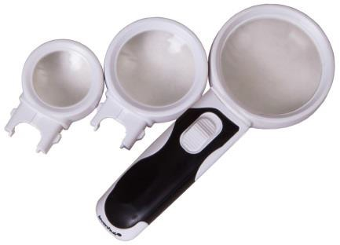
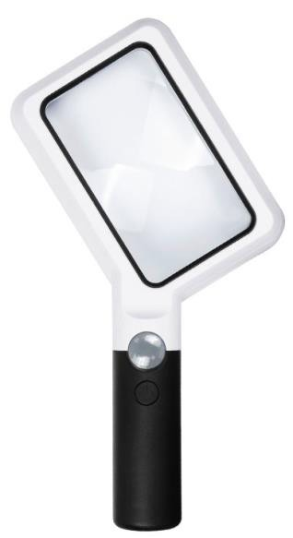
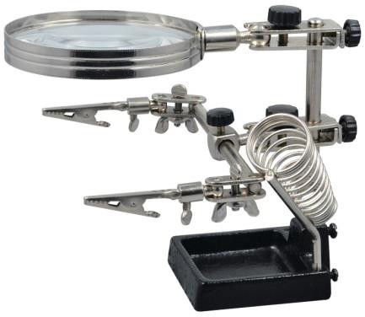
Levenhuk Zeno Multi
Multifunctional magnifiers come with interchangeable lenses and built-in illumination. The Levenhuk Zeno Multi Magnifiers are suitable for solving a wide range of tasks, from reading to professional activities that require high accuracy and precision.

The series includes:
72601 Levenhuk Zeno Multi ML3 72602 Levenhuk Zeno Multi ML5 72603 Levenhuk Zeno Multi ML7 72604 Levenhuk Zeno Multi ML9

Main Features:
    - Some-in-one magnifiers

72605 Levenhuk Zeno Multi ML11 72606 Levenhuk Zeno Multi ML13
72607 Levenhuk Zeno Multi ML15, White 72608 Levenhuk Zeno Multi ML17, Black

    - Interchangeable lenses included in the kit
    - Illumination: LED lights
    - Some models feature a “third hand” holder and special soldering iron holder.

Levenhuk Zeno Read
These magnifiers are designed for reading, so they feature rectangular lenses that capture a wide part of the observing an object or a text.

The series includes:
74066 Levenhuk Zeno Read ZR10, White 74067 Levenhuk Zeno Read ZR10, Black 74068 Levenhuk Zeno Read ZR12

Main Features:

74069 Levenhuk Zeno Read ZR14 74100 Levenhuk Zeno Read ZR16 74101 Levenhuk Zeno Read ZR18 74102 Levenhuk Zeno Read ZR20

    - Convenient handles and rectangular lens
    - Uniform LED illumination
    - There are models with additional lenses in the kit
    - Excellent for studying drafts, geography maps, schemes, engravings, and small texts.

Levenhuk Zeno Refit
Stand magnifiers for performing precise work. All the magnifiers in this series have “third hand” holders that securely fix an object.

The series includes:
74070 Levenhuk Zeno Refit ZF7 74071 Levenhuk Zeno Refit ZF9 74072 Levenhuk Zeno Refit ZF11 74073 Levenhuk Zeno Refit ZF13

74074 Levenhuk Zeno Refit ZF15 74075 Levenhuk Zeno Refit ZF17 74076 Levenhuk Zeno Refit ZF19 74077 Levenhuk Zeno Refit ZF21

Main Features:
    - Suitable for watch or jewelry repair, fixing electronics parts, soldering, or painting any details.
    - Special holders with clamps that allow for fixing objects tightly in one position
    - Some magnifiers of the series feature lights
    - Durable metal stands

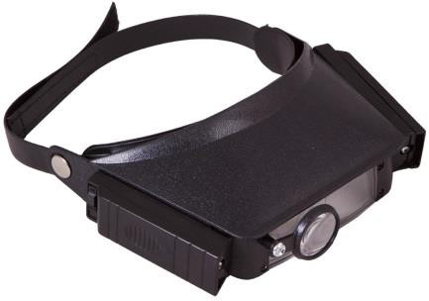
Levenhuk Zeno Vizor
Convenient magnifiers for professional use. The series includes head and neck magnifiers, as well as magnifying glasses powered by batteries or a rechargeable battery.
Head Magnifiers:
69668 Levenhuk Zeno Vizor H1
69669 Levenhuk Zeno Vizor H2
69670 Levenhuk Zeno Vizor H3
70433 Levenhuk Zeno Vizor H4
72611 Levenhuk Zeno Vizor H7

Head Rechargeable Magnifiers:
72613 Levenhuk Zeno Vizor HR2
72614 Levenhuk Zeno Vizor HR4
72615 Levenhuk Zeno Vizor HR6
Levenhuk DTX 43 Digital Magnifier

This optical tool has four fixed magnifications and seven color modes for displaying text. You can connect a magnifying glass to a computer or TV, take screenshots while working, and save them to a memory card. The magnifiers are battery or mains powered.
This magnifying tool is very easy to use. Simply hold it over the text and move it around as you read. An enlarged image is instantly displayed on the built-in LCD screen.

Neck Magnifiers:
69674 Levenhuk Zeno Vizor N1
69675 Levenhuk Zeno Vizor N2

Magnifying Glasses:
70431 Levenhuk Zeno Vizor G0
69671 Levenhuk Zeno Vizor G1
69672 Levenhuk Zeno Vizor G2
69673 Levenhuk Zeno Vizor G3
70432 Levenhuk Zeno Vizor G4
72609 Levenhuk Zeno Vizor G5
72612 Levenhuk Zeno Vizor G6
72610 Levenhuk Zeno Vizor G7
74106 Levenhuk Zeno Vizor G8

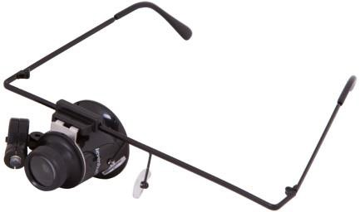

Main Features:

- Most models are equipped with a built-in illumination
- With these glasses you can always have your hands free while doing high precision work
- Wide scope of application
- Shockproof lenses made of optical glass

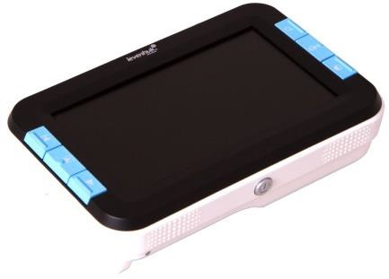
Main Features:
- LCD-screen 4.3''
- 7 color modes
- TV or PC connection
- Manual focusing
- Four fixed magnifications
- LED illumination
- Battery life is up to120 minutes
- Memory card support
- Freeze-frame function
- Photo-shooting function
- Foldable stand

